UC1-Customer Login

Short description.
Customer comes to the site and enters phone number or account number and password. System validates it and allows customer to see his Account Summary screen. If Customer never been to the web site, he chooses to register. During registration, he enters his acct number, email, password and password confirmation. If Customer forgot the password , he enters acct id and system emails him password.

Login Main Flow
- Customer Enters Phone Number or Account Number and Password
- System validates Phone Number or Account Number, password
- System records the fact that customer visited the site
- System shows Account Summary Screen

Alternative flows
2.A Phone number or Account Number and Password combination is not correct
1. System shows the message "Invalid Phone Number (or Account Number if user entered account number) or Password "
2.B Customer is not setup yet in the web system
1. System shows the message "Please Sign Up to access your account for the first time"
2.C Password is a temporary password
1. System asks user to reset the password . Message: Please reset your temporary password. Show two boxes Password and Confirm Password
2.User enters new password
3. System updates the password and marks temporary password flag as false
4. Go to step 3 of main flow

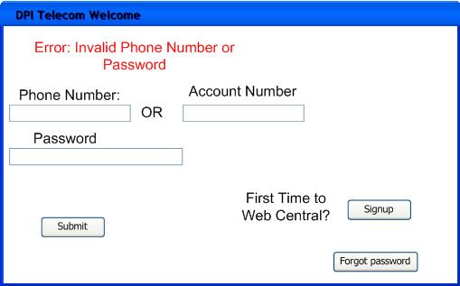

Sign Up main flow
- Customer chooses to sign up for new service
- Enters Account Number, Email, Password, Password confirmation
- System checks if password and password confirmation match.
- System checks if account number is valid
- System checks that this is the first time customer tries to login to public website
- System records the fact that customer logged in into public website
- System shows account summary page
- System email message to the customer that his web access is setup.

Alternative flows:
3.A Password and Password confirmation does not match
1. System shows error message that password does not match
4.A Account Number is not valid
1. System shows message "Invalid Account Number"
5.A System finds that customer already has signup to public website before.
1. System shows sign up screen with the message that "Account already signed up."

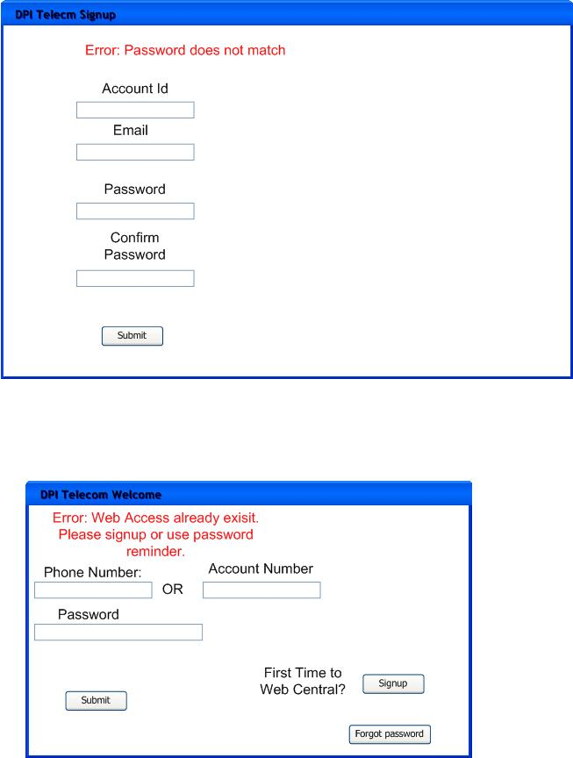

Password reminder flow
- Customer enters account number
- System validates that account number is valid
- System validates that customer has signed up for public website
- System generates temporary password 7 random chars
- System updates customer record with temporary password
- System set temporary pwd flag to true
- System sends temporary password to customer's email address
- System show message "Thank you Joe. Your password was sent to your email address"

flows
2.A Account Number is not valid:
1. System shows message "Invalid Account Number"
3.A Customer has never signup for public website
1. System shows message "Please select the link Web Access Sign Up to setup access for your account" and shows signup screen
